Conway’s game of life :
(logic + abstract code implementation by Ismail Nouari )
1 => understanding the logic :

the game is consists of a grid of cells (you can define the number of cells and their sizes by your self ) => so the game is a matrix of cells ….

-----each cell has two states : died or alive ;
-----each cell has 8 neighbors (cells)
-----there is three rules for (live , die , born) ;

As the game develops level by level , the state of every cell may changes in every level with the following logic :

1)=> if the cell has 3 or 2 alive neighbors it will stay alive . (if it is not alive it becomes alive)
2)=> if the cell has more then 3 or less then 2 alive neighbors then I will die .

*** the game could start by random alive cells or using a specific shapes (we will use functions to draw them)

#### before drawing the game on the browser window , we must build the main grid (matrix) and its basic functions :

for that we will use the principle of oriented object programming (the game should be a class)

=> the game has a specific attributes (nbr of columns , nbr of rows , the size of the cell , a boolean variable that indicates the state of the game is running or not , and also has a matrix that represents the grid)

=>the game also has methods like ( countneighbors , randomize…….)

2 => building the game class: (to build the game logic implementation using matrix (3d array data structure))
** first we define game as any js class :

*=> 1 : the main constractor: (its role is to initialize the attributes of the game )

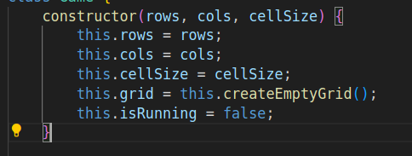

* 2 => the method createEmptyGrid :

this method returns array(of rows ) and for each row its create inside an array of columns ;

*3 => the randomize funciton :

this funciton will loop throw the entire matrix and use the
math.random function to randomly chouse some cells in the
matrix to be alive

*4 => CountNeighbors function :

this function uses for loop counr of alive neibors :
the abstract code : (it takes row and col as inputs and return cpt as an output)

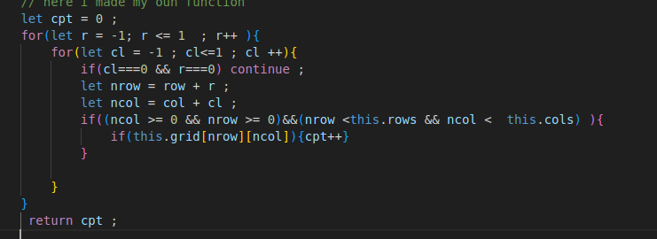

*5 = update function :

as we say previously that state of the grid cells changes level by level
so for this we must create a function that checks the number of the alive
neighbors using countNeighbors method
and after that defining the state of every cell in the next level
(I will follows this two rules ):
1)=> if the cell has 3 or 2 alive neighbors it will stay alive . (if it is not alive it becomes alive)
2)=> if the cell has more then 3 or less then 2 alive neighbors then I will die .
3=> create the rendering class:
( to be displayed on the screen)

******* first I should get some knowledge about the canvas tag in html ********

so for this I will :
--follow some canvas tutorials on youtube
--check the mdn documentation : mdn canvas

the renedering class must have some attributes :
* the game object
* canvas (an attribute that refers to the html canvas tag)
* canvas contax 2d (that will help us to draw any shape )

we must define a cunstractor method that initialize the attrubutes and setting the canvas width and height

after that we will create the draw function that create our gird using this logic :
a nested for loop with two vars I and j ;
based on game.grid[j][i] we will design some rectangles
we will follow this law:
if game.grid[j][i] == true then we will draw a rectangle with position
x = I * game.cellSize ;
y = j * game.cellSize ;

width and height must be cellSize -1 to let some marging between the cells
fillRect(x, y, width, height)
===> combing them in fillRect(x, y, width, height) ;
for now …, we know how to create the rectangles

once the the document loaded the event onload will fires and
we can :
* create game objct
* create renderer object using its constructor
* create event listeners for the buttons
* draw the game at the end

**** for now we should handle the buttons with click events******

1 = it is easy to handle the click events so :

start button click => will start the game by creating a time interval with 1ms that update the game matrix using the update function and draw the renderer again every interval
randomize button click => create a new game and fill the cells randomly and draw the renderer

clear button click => will create a new game with only dead cells and redraw the renderer (the new game)

